**React HandsOn**

**EXERCISE-9:**

Create a React Application named “cricketapp” with the following components:

1. ListofPlayers

* Declare an array with 11 players and store details of their names and scores using the map feature of ES6
* import React from 'react';
* const ListofPlayers = ({ players }) => {
* return (
* <ul>
* {players.map((item, index) => (
* <li key={index}>
* Mr. {item.name} <span>{item.score}</span>
* </li>
* ))}
* </ul>
* );
* };
* export default ListofPlayers;
* **Filter the players with scores below 70 using arrow functions of ES6.**
* import React from 'react';
* const ScoreBelow70 = ({ players }) => {
* const players70 = [];
* players.map((item) => {
* if (item.score <= 70) {
* players70.push(item);
* }
* return null;
* });
* return (
* <ul>
* {players70.map((item, index) => (
* <li key={index}>
* Mr. {item.name} <span>{item.score}</span>
* </li>
* ))}
* </ul>
* );
* };
* export default ScoreBelow70;

1. IndianPlayers

* Declare two arrays T20players and RanjiTrophy players and merge the two arrays and display them using the Merge feature of ES6
* export const IndianTeam = ['Sachin1', 'Dhoni2', 'Virat3', 'Rohit4', 'Yuvaraj5', 'Raina6'];
* const T20Players = ['First Player', 'Second Player', 'Third Player'];
* const RanjiTrophyPlayers = ['Fourth Player', 'Fifth Player', 'Sixth Player'];
* export const IndianPlayers = [...T20Players, ...RanjiTrophyPlayers];
  + Display the Odd Team Player and Even Team players using the Destructuring features of ES6

1. export function OddPlayers([first, , third, , fifth]) {
2. return (
3. <div>
4. <li>First : {first}</li>
5. <li>Third : {third}</li>
6. <li>Fifth : {fifth}</li>
7. </div>
8. );
9. }
10. export function EvenPlayers([, second, , fourth, , sixth]) {
11. return (
12. <div>
13. <li>Second : {second}</li>
14. <li>Fourth : {fourth}</li>
15. <li>Sixth : {sixth}</li>
16. </div>
17. );
18. }

**App.js**

import React from 'react';

import ListOfPlayers from './components/ListOfPlayers';

import ScoreBelow70 from './components/ScoreBelow70';

import { OddPlayers } from './components/OddPlayers';

import { EvenPlayers } from './components/EvenPlayers';

import ListofIndianPlayers from './components/ListofIndianPlayers';

import { IndianPlayers, IndianTeam } from './components/IndianTeamData';

function App() {

  const flag = false;

  const players = [

    { name: 'Jack', score: 50 },

    { name: 'Michael', score: 70 },

    { name: 'John', score: 40 },

    { name: 'Ann', score: 61 },

    { name: 'Elisabeth', score: 61 },

    { name: 'Sachin', score: 95 },

    { name: 'Dhoni', score: 100 },

    { name: 'Virat', score: 84 },

    { name: 'Jadeja', score: 64 },

    { name: 'Raina', score: 75 },

    { name: 'Rohit', score: 80 }

  ];

  if (flag === true) {

    return (

      <div>

        <h1>List of Players</h1>

        <ListOfPlayers players={players} />

        <hr />

        <h1>List of Players having Scores Less than 70</h1>

        <ScoreBelow70 players={players} />

      </div>

    );

  } else {

    return (

      <div>

        <div>

          <h1>Indian Team</h1>

          <h1>Odd Players</h1>

          {OddPlayers(IndianTeam)}

          <hr />

          <h1>Even Players</h1>

          {EvenPlayers(IndianTeam)}

        </div>

        <hr />

        <div>

          <h1>List of Indian Players Merged:</h1>

          <ListofIndianPlayers IndianPlayers={IndianPlayers} />

        </div>

      </div>

    );

  }

}

export default App;

In terminal run npm start

**Output:**

If flag=false

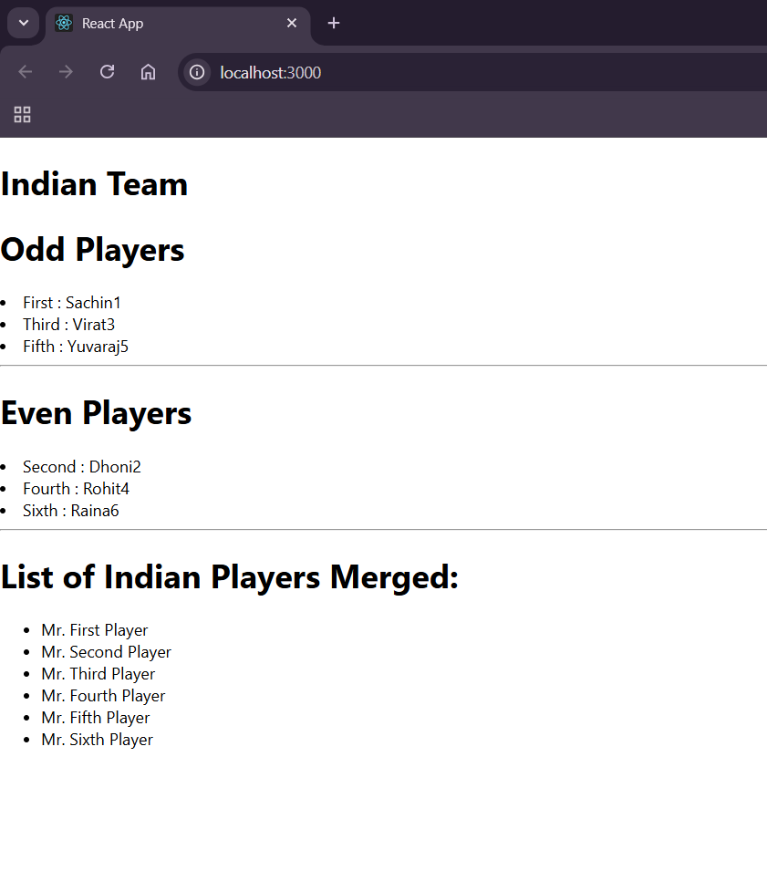

**If flag==true**

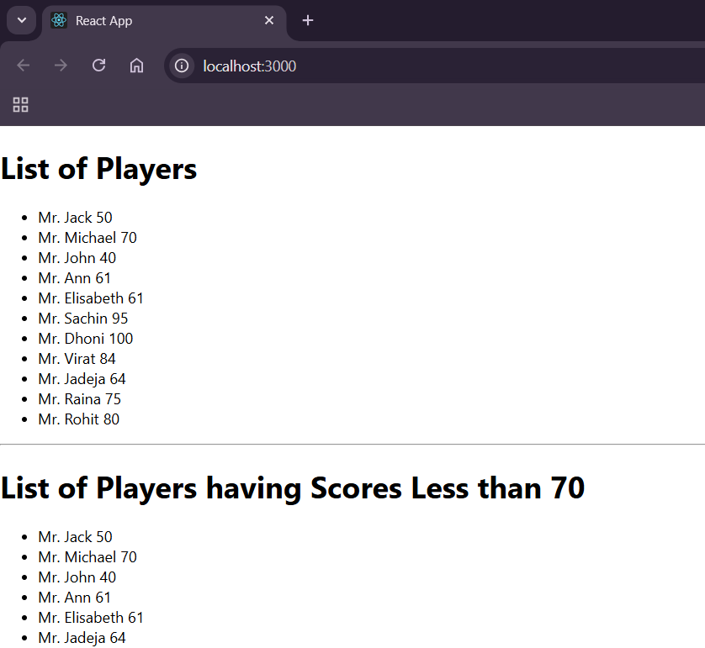

**Exercise-10:**

Create an element to display the heading of the page.

Attribute to display the image of the office space

Create an object of office to display the details like Name, Rent and Address.

Create a list of Object and loop through the office space item to display more data.

To apply Css, Display the color of the Rent in Red if it’s below 60000 and in Green if it’s above 60000.

**App.js**

import React from "react";

import "./App.css";

function App() {

  const heading = <h1>Office Space Rental Portal</h1>;

  const office = {

    name: "TechHub Co-Working",

    rent: 55000,

    address: "2nd Floor, Tower B, Sector 62, Noida"

  };

  const officeSpaces = [

    {

      name: "TechHub Co-Working",

      rent: 55000,

      address: "2nd Floor, Tower B, Sector 62, Noida"

    },

    {

      name: "Innovate Office",

      rent: 75000,

      address: "1st Floor, Cyber City, Gurgaon"

    },

    {

      name: "Startup Space",

      rent: 48000,

      address: "3rd Floor, Hinjewadi Phase 1, Pune"

    }

  ];

  const getRentStyle = (rent) => {

    return {

      color: rent < 60000 ? "red" : "green"

    };

  };

  return (

    <div className="App">

      {heading}

      <img

        src="office.jpg"

        alt="Office Space"

        width="400"

      />

      <h2>Featured Office:</h2>

      <p>Name: {office.name}</p>

      <p style={getRentStyle(office.rent)}>Rent: ₹{office.rent}</p>

      <p>Address: {office.address}</p>

      <h2>All Available Office Spaces:</h2>

      {officeSpaces.map((space, index) => (

        <div key={index}>

          <p>Name: {space.name}</p>

          <p style={getRentStyle(space.rent)}>Rent: ₹{space.rent}</p>

          <p>Address: {space.address}</p>

        </div>

      ))}

    </div>

  );

}

export default App;

**Output:**

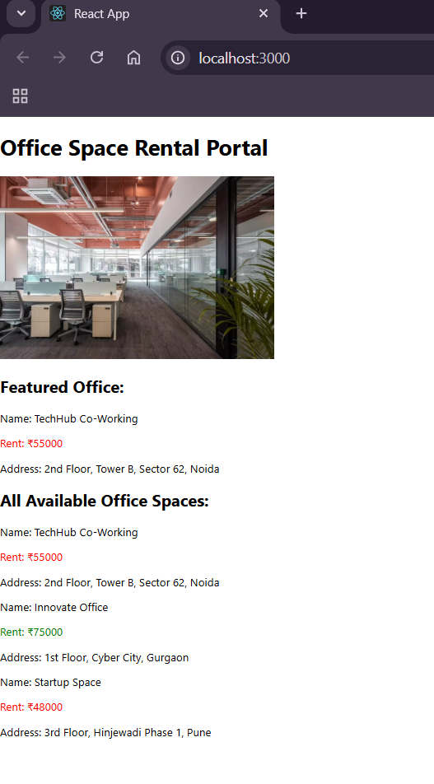

**Exercise-11**

1. Create “Increment” button to increase the value of the counter and “Decrement” button to decrease the value of the counter. The “Increase” button should invoke multiple methods.
   1. To increment the value
   2. Say Hello followed by a static message.
2. Create a button “Say Welcome” which invokes the function which takes “welcome” as an argument.
3. Create a button which invokes synthetic event “OnPress” which display “I was clicked”
4. Create a “CurrencyConvertor” component which will convert the Indian Rupees to Euro when the Convert button is clicked and Handle the Click event of the button to invoke the handleSubmit event and handle the conversion of the euro to rupees.

**App.js**

import React, { useState } from "react";

import "./App.css";

function App() {

  const [count, setCount] = useState(0);

  const [rupees, setRupees] = useState("");

  const [euros, setEuros] = useState("");

  const handleIncrement = () => {

    sayHello();

    setCount(count + 1);

  };

  const sayHello = () => {

    console.log("Hello! This is the increment button.");

  };

  const handleDecrement = () => {

    setCount(count - 1);

  };

  const sayWelcome = (msg) => {

    alert(msg);

  };

  const handleClick = (e) => {

    e.preventDefault();

    alert("I was clicked");

  };

  const handleRupeeChange = (e) => {

    setRupees(e.target.value);

  };

  const handleSubmit = () => {

    const euroValue = parseFloat(rupees) / 90;

    setEuros(euroValue.toFixed(2));

  };

  return (

    <div style={{ margin: "40px" }}>

      <p>Value: {count}</p>

      <button onClick={handleIncrement}>Increment</button>

      <button onClick={handleDecrement} style={{ marginLeft: "10px" }}>

        Decrement

      </button

      <button onClick={() => sayWelcome("Welcome to the React App!")}>

        Say Welcome

      </button>

      <button onClick={handleClick}>Click Me</button>

      <h2>Currency Converter</h2>

      <input

        type="number"

        value={rupees}

        onChange={handleRupeeChange}

        placeholder="Enter amount in ₹"

      />

      <button onClick={handleSubmit} style={{ marginLeft: "10px" }}>

        Convert to Euro

      </button>

      {euros && <p>Converted Amount: €{euros}</p>}

    </div>

  );

export default App;

**App.css**

button {

  margin: 10px 5px;

  padding: 5px 10px;

  font-size: 16px;

}

input {

  padding: 5px;

  font-size: 16px;

}

**Output:**

**1.**

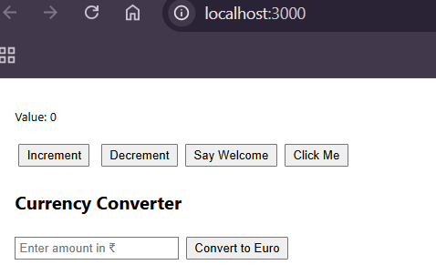

**After clicking increment button for 3 times:**

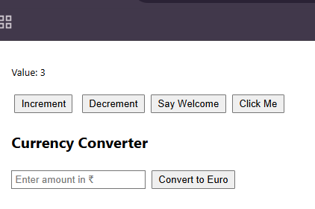

**Clicking decrement button:**

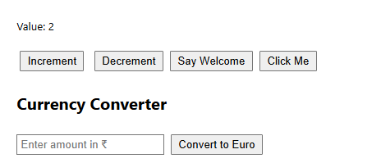

**Clicking say welcome button**

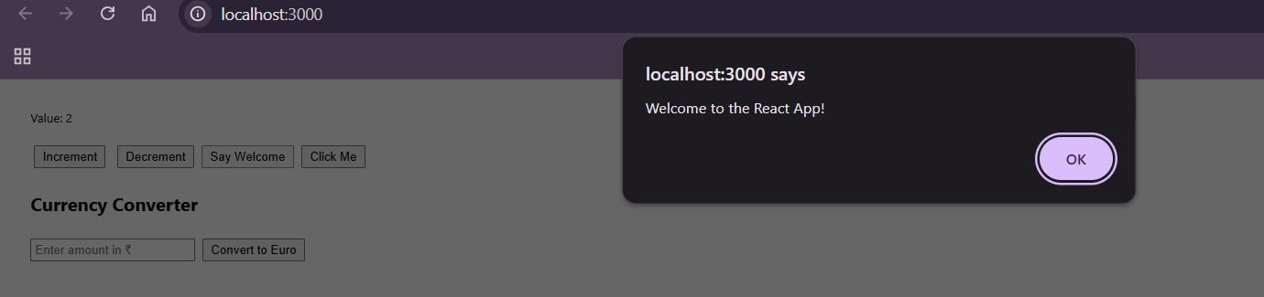

**Clicking click me button:**

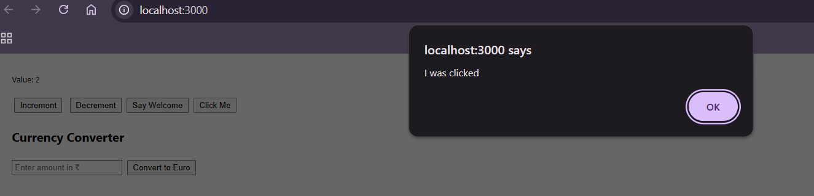

**Converting Indian rupees to euros**

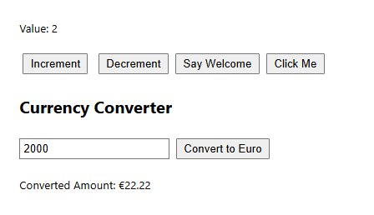

**EXERCISE-12:**

Create a React Application named “ticketbookingapp” where the guest user can browse the page where the flight details are displayed whereas the logged in user only can book tickets.

The Login and Logout buttons should accordingly display different pages. Once the user is logged in the User page should be displayed. When the user clicks on Logout, the Guest page should be displayed**.**

**App.js**

import React, { useState } from "react";

import "./App.css";

function App() {

  const [isLoggedIn, setIsLoggedIn] = useState(false);

  const handleLogin = () => setIsLoggedIn(true);

  const handleLogout = () => setIsLoggedIn(false);

  let content;

  if (isLoggedIn) {

    content = <UserPage onLogout={handleLogout} />;

  } else {

    content = <GuestPage onLogin={handleLogin} />;

  }

  return (

    <div className="App" style={{ margin: "40px" }}>

      <h1>Flight Ticket Booking App</h1>

      {content}

    </div>

  );

}

function GuestPage({ onLogin }) {

  return (

    <div>

      <h2>Welcome Guest!</h2>

      <p>Here are today's available flights:</p>

      <ul>

        <li>Delhi → Mumbai @ ₹4500</li>

        <li>Bangalore → Kolkata @ ₹5500</li>

        <li>Hyderabad → Pune @ ₹4000</li>

      </ul>

      <button onClick={onLogin}>Login to Book Tickets</button>

    </div>

  );

}

function UserPage({ onLogout }) {

  return (

    <div>

      <h2>Welcome Back, User!</h2>

      <p>You can now book your tickets:</p>

      <ul>

        <li>Delhi → Mumbai <button>Book</button></li>

        <li>Bangalore → Kolkata <button>Book</button></li>

        <li>Hyderabad → Pune <button>Book</button></li>

      </ul>

      <button onClick={onLogout}>Logout</button>

    </div>

  );

}

export default App;

**Output:**

**When user looged out guest page:**

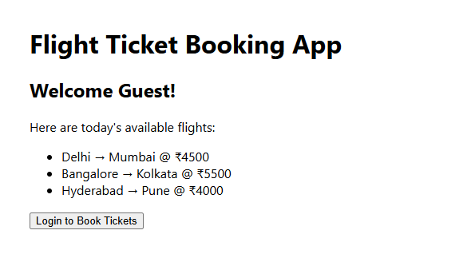

**When the user logged in booking details:**

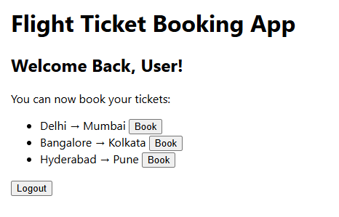

**EXERCISE-13:**

Create a React App named “bloggerapp” in with 3 components.

1. Book Details
2. Blog Details
3. Course Details

Implement this with as many ways possible of Conditional Rendering.

**App.js**

import React, { useState } from "react";

import "./App.css";

import BookDetails from "./components/BookDetails";

import BlogDetails from "./components/BlogDetails";

import CourseDetails from "./components/CourseDetails";

function App() {

  const [selected, setSelected] = useState("book")

  let content;

  if (selected === "book") {

    content = <BookDetails />;

  } else if (selected === "blog") {

    content = <BlogDetails />;

  } else {

    content = <CourseDetails />;

  }

  return (

    <div className="App" style={{ margin: "40px" }}>

      <h1>Blogger App</h1>

      <div style={{ marginBottom: "20px" }}>

        <button onClick={() => setSelected("book")}>Book</button>

        <button onClick={() => setSelected("blog")}>Blog</button>

        <button onClick={() => setSelected("course")}>Course</button>

      </div>

      {content}

    </div>

  );

}

export default App;

**BookDetails.js**

import React from "react";

const books = [

  { id: 1, title: "Learning React", author: "Alex Banks" },

  { id: 2, title: "Clean Code", author: "Robert C. Martin" },

  { id: 3, title: "JavaScript: The Good Parts", author: "Douglas Crockford" },

  { id: 4, title: "You Don't Know JS", author: "Kyle Simpson" },

  { id: 5, title: "The Pragmatic Programmer", author: "Andrew Hunt" },

  { id: 6, title: "Fullstack React", author: "Anthony Accomazzo" },

  { id: 7, title: "Refactoring UI", author: "Adam Wathan" }

];

function BookDetails() {

  return (

    <div>

      <h2>Book List</h2>

      {books.length > 0 ? (

        <ul>

          {books.map((book) => (

            <li key={book.id}>

              <b>{book.title}</b> by {book.author}

            </li>

          ))}

        </ul>

      ) : (

        <p>No books found.</p>

      )}

    </div>

  );

}

export default BookDetails;

**BlogDetails.js**

import React from "react";

const blogs = []

function BlogDetails() {

  return (

    <div>

      <h2>Blog Posts</h2>

      {blogs.length === 0 && <p>No blog posts available.</p>}

      {blogs.length > 0 ? (

        <ul>

          {blogs.map((blog, index) => (

            <li key={index}>{blog}</li>

          ))}

        </ul>

      ) : null}

    </div>

  );

export default BlogDetails

**CourseDetails.js**

import React from "react";

const courses = ["ReactJS", "Node.js", "MongoDB", "Express"];

function CourseDetails() {

  return (

    <div>

      <h2>Courses</h2>

      <ul>

        {courses.map((course, index) => (

          <li key={index}>{course}</li>

        ))}

      </ul>

    </div>

  );

}

export default CourseDetails;

**Output:**

